Voluntary Improvisation: Fanfare on Easter Hymn

Procession Hymn 207 Jesus Christ is risen today Easter Hymn

Opening Acclamation (said three times)
Alleluia. Christ is risen.

The Lord is risen indeed. Alleluia.

Collect for Purity
Almighty God, unto whom all hearts are open, all desires known, and from whom no secrets are hid: Cleanse the thoughts of our hearts by the inspiration of thy Holy Spirit, that we may perfectly love thee, and worthily magnify thy holy Name; through Christ our Lord. Amen.

Gloria
All sing and ring bells or chimes.
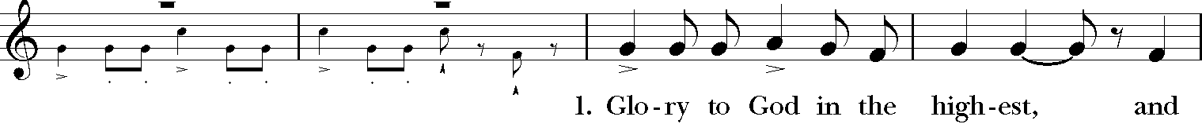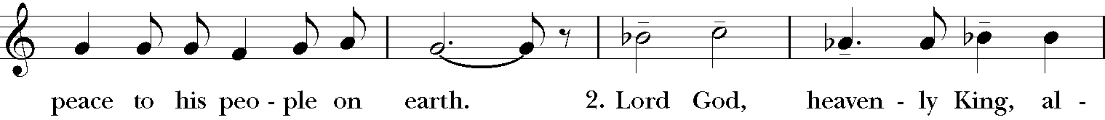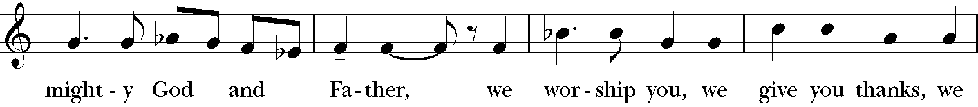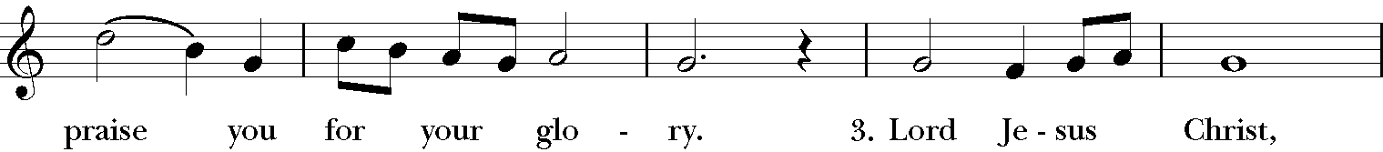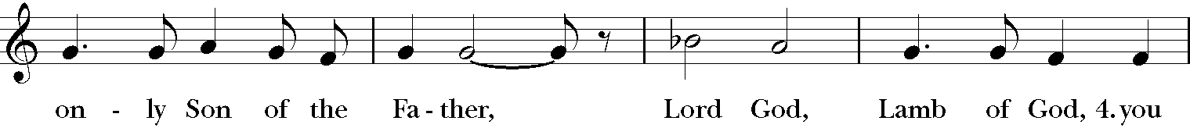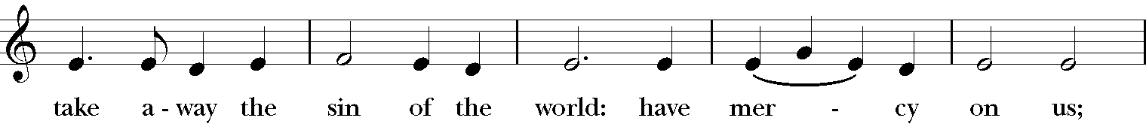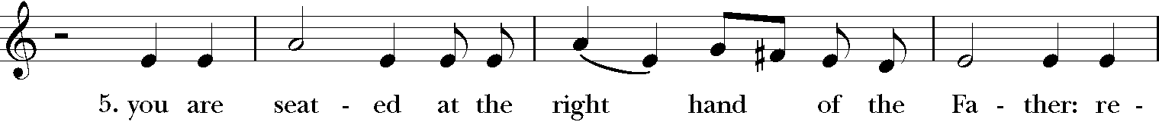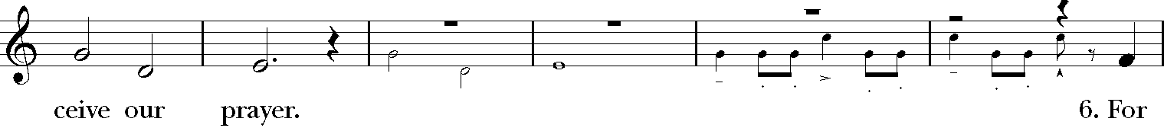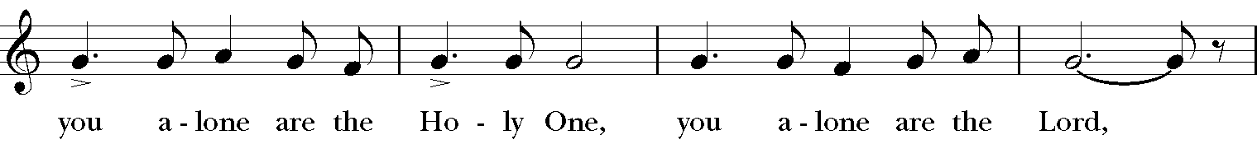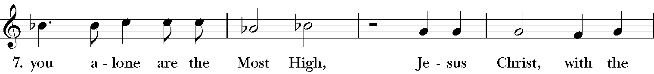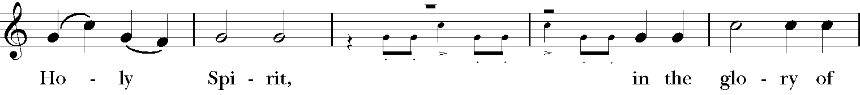
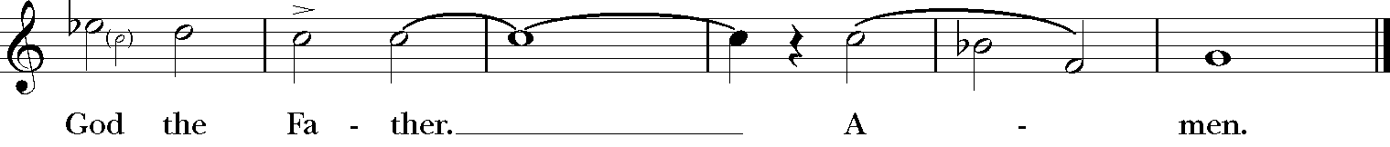

The Word of God

The Collect of the Day
The Lord be with you.

And with thy spirit.
Let us pray.
Almighty God, who through thine only-begotten Son Jesus Christ hast overcome death and opened unto us the gate of everlasting life: Grant that we, who celebrate with joy the day of the Lord’s resurrection, may be raised from the death of sin by your life-giving Spirit; through the same Jesus Christ our Lord, who liveth and reigneth with thee and the same Spirit ever, one God, world without end. Amen.

Acts 10:34-43
Peter began to speak to Cornelius and the other Gentiles: "I truly understand that God shows no partiality, but in every nation anyone who fears him and does what is right is acceptable to him. You know the message he sent to the people of Israel, preaching peace by Jesus Christ--he is Lord of all. That message spread throughout Judea, beginning in Galilee after the baptism that John announced: how God anointed Jesus of Nazareth with the Holy Spirit and with power; how he went about doing good and healing all who were oppressed by the devil, for God was with him. We are witnesses to all that he did both in Judea and in Jerusalem. They put him to death by hanging him on a tree; but God raised him on the third day and allowed him to appear, not to all the people but to us who were chosen by God as witnesses, and who ate and drank with him after he rose from the dead. He commanded us to preach to the people and to testify that he is the one ordained by God as judge of the living and the dead. All the prophets testify about him that everyone who believes in him receives forgiveness of sins through his name."

The Word of the Lord.
Thanks be to God.

Gradual Hymn 199 Come, ye faithful (st. 1, 2, 4) St. Kevin

Colossians 3:1-4

If you have been raised with Christ, seek the things that are above, where Christ is, seated at the right hand of God. Set your minds on things that are above, not on things that are on earth, for you have died, and your life is hidden with Christ in God. When Christ who is your life is revealed, then you also will be revealed with him in glory.
The Word of the Lord.
Thanks be to God.

The Sequence Hymn The strife is o’er, the battle done Victory

John 20:1-18
The Holy Gospel of our Lord Jesus Christ according to John.

Glory be to thee, O Lord.
Early on the first day of the week, while it was still dark, Mary Magdalene came to the tomb and saw that the stone had been removed from the tomb. So she ran and went to Simon Peter and the other disciple, the one whom Jesus loved, and said to them, “They have taken the Lord out of the tomb, and we do not know where they have laid him.” Then Peter and the other disciple set out and went toward the tomb. The two were running together, but the other disciple outran Peter and reached the tomb first. He bent down to look in and saw the linen wrappings lying there, but he did not go in. Then Simon Peter came, following him, and went into the tomb. He saw the linen wrappings lying there, and the cloth that had been on Jesus’ head, not lying with the linen wrappings but rolled up in a place by itself. Then the other disciple, who reached the tomb first, also went in, and he saw and believed; for as yet they did not understand the scripture, that he must rise from the dead. Then the disciples returned to their homes.
But Mary stood weeping outside the tomb. As she wept, she bent over to look into the tomb; and she saw two angels in white, sitting where the body of Jesus had been lying, one at the head and the other at the feet. They said to her, “Woman, why are you weeping?” She said to them, “They have taken away my Lord, and I do not know where they have laid him.” When she had said this, she turned around and saw Jesus standing there, but she did not know that it was Jesus. Jesus said to her, “Woman, why are you weeping? Whom are you looking for?” Supposing him to be the gardener, she said to him, “Sir, if you have carried him away, tell me where you have laid him, and I will take him away.” Jesus said to her, “Mary!” She turned and said to him in Hebrew, “Rabbouni!” (which means Teacher). Jesus said to her, “Do not hold on to me, because I have not yet ascended to the Father. But go to my brothers and say to them, ‘I am ascending to my Father and your Father, to my God and your God.’” Mary Magdalene went and announced to the disciples, “I have seen the Lord”; and she told them that he had said these things to her.
The Gospel of the Lord.

Glory be to thee, O Lord.
Sermon
The Renewal of Baptismal Vows
All stand. The Paschal Candle leads the clergy to the baptismal font. The People are invited to gather around the font.
Gathering Hymn 296 We know that Christ is raised (st 1-2)
We know that Christ is raised and dies no more.
Embraced by death, he broke its fearful hold,
and our despair he turned to blazing joy. Alleluia!
We share by water in his saving death.
Reborn, we share with him an Easter life
as living members of a living Christ. Alleluia!

Through the Paschal mystery, dear friends, we are buried with Christ by Baptism into his death, and raised with him to newness of life. I call upon you, therefore, now that our Lenten observance is ended, to renew the solemn promises and vows of Holy Baptism, by which we once renounced Satan and all his works, and promised to serve God faithfully in his holy Catholic Church.

Do you reaffirm your renunciation of evil and renew your commitment to Jesus Christ?
I do.
Do you believe in God the Father?
I believe in God, the Father almighty,
creator of heaven and earth.
Do you believe in Jesus Christ, the Son of God?
I believe in Jesus Christ, his only Son, our Lord.
He was conceived by the power of the Holy Spirit
and born of the Virgin Mary.
He suffered under Pontius Pilate,
was crucified, died, and was buried.
He descended to the dead.
On the third day he rose again.
He ascended into heaven,
and is seated at the right hand of the Father.
He will come again to judge the living and the dead.
Do you believe in God the Holy Spirit?
I believe in the Holy Spirit,
the holy catholic Church,
the communion of saints,
the forgiveness of sins,
the resurrection of the body,
and the life everlasting.
Will you continue in the apostles’ teaching and fellowship, in the breaking of bread, and in the prayers?
I will, with God’s help.
Will you persevere in resisting evil, and, whenever you fall into sin, repent and return to the Lord?
I will, with God’s help.
Will you proclaim by word and example the Good News of God in Christ?
I will, with God’s help.
Will you seek and serve Christ in all persons, loving your neighbor as yourself?
I will, with God’s help.
Will you strive for justice and peace among all people, and respect the dignity of every human being?
I will, with God’s help.

Thanksgiving over the Water
The Lord be with you.
And with thy spirit.
Let us give thanks unto our Lord God.
It is meet and right so to do.

We give thee thanks, Almighty God, for the gift of water, over which thy Holy Spirit moved in the beginning of creation; through which thou didst lead the children of Israel out of their bondage in Egypt into the land of promise; in which thy Son Jesus Christ received the baptism of John and the anointing of the Holy Spirit, being manifested thereby as the Messiah, the Christ, who leadeth us, through his precious death and mighty resurrection, from the bondage of sin unto life everlasting.

We give thee thanks, O Father, for the water of Baptism, in which we are buried with Christ in his death; by which we partake of his resurrection; through which we are made regenerate of the Holy Spirit. Therefore in joyful obedience to thy Son, we bring into his fellowship them that come to him in faith, baptizing them in the Name of the Father, and of the Son, and of the Holy Spirit.

Now sanctify this water, we beseech thee, by thy Holy Spirit, that those here cleansed from sin and made regenerate may continue forever in the risen life of Jesus Christ our Savior, to whom, with thee and the same Holy Spirit, be all honor and glory, now and forever. Amen.

The clergy asperge the people with water from the font.

Hymn 296 We know that Christ is raised (st 3-4)

The Father’s splendor clothes the Son with life.
The Spirit's power shakes the Church of God.
Baptized, we live with God the Three in One. Alleluia!
A new creation comes to life and grows
as Christ's new body takes on flesh and blood.
The universe restored and whole will sing: Alleluia!

Clergy
May Almighty God, the Father of our Lord Jesus Christ, who has given us a new birth by water and the Holy Spirit, and bestowed upon us the forgiveness of sins, keep us in eternal life by his grace, in Christ Jesus our Lord. Amen.

Peace
The peace of the Lord be always with you.
And with thy spirit.

Welcome & Announcements

If you would like to give online, use your phone’s camera to scan this QR code.

The Holy Communion

Offertory Anthem A song to the Lamb Gerre Hancock
sung by the choir

Splendor and honor and kingly power are yours by right, O Lord our God,
for you created ev’rything that is, and by your will they were created,
and have their being.
And yours by right, O Lamb that was slain,
for with your Blood you have redeem’d for God,
from ev’ry fam’ly language, people and nation,
a kingdom of priests to serve our God.
And so, to him who sits upon the throne, and to Christ the Lamb,
be worship and praise, dominion and splendor,
forever, and forevermore. Alleluia!
Great Thanksgiving: Prayer 2
The Lord be with you.
And with thy spirit.
Lift up your hearts.
We lift them up unto the Lord.
Let us give thanks to the Lord our God.
It is meet and right so to do.

It is very meet, right, and our bounden duty, that we should at all times, and in all places, give thanks unto thee, O Lord, holy Father, almighty, everlasting God. But chiefly are we bound to praise thee for the glorious
resurrection of thy Son Jesus Christ our Lord; for he is the very Paschal Lamb, who was sacrificed for us, and hath taken away the sin of the world; who by his death hath destroyed death, and by his rising to life again hath won for us everlasting life.

Therefore with Angels and Archangels, and with all the company of heaven, we laud and magnify thy glorious Name; evermore praising thee, and saying,

Sanctus William Mathias

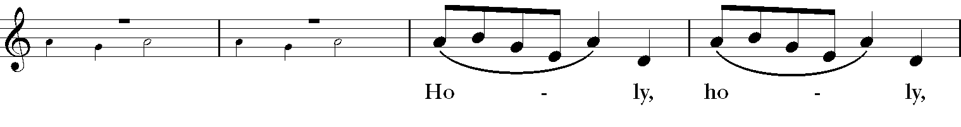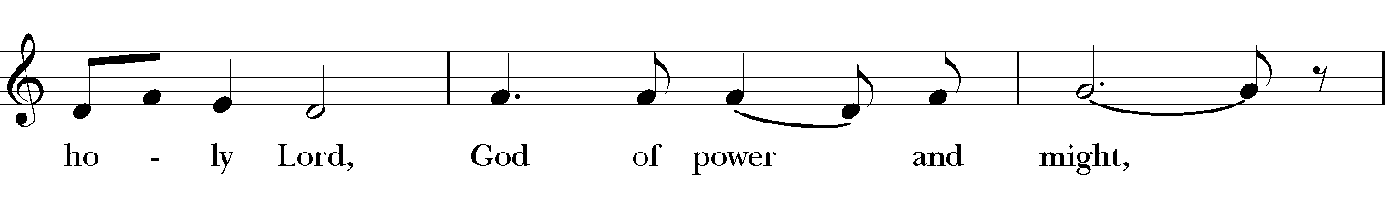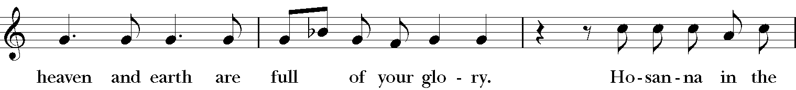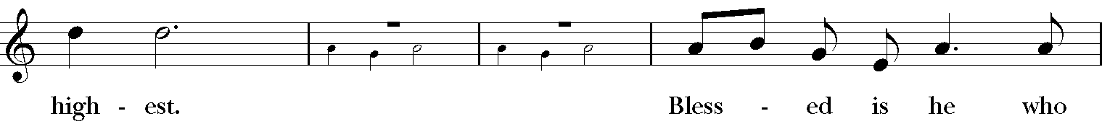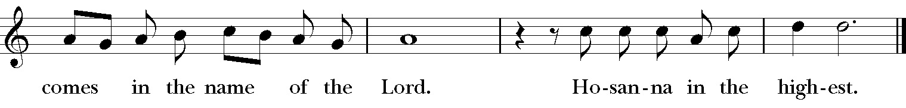

All glory be to thee, O Lord our God, for that thou didst create heaven and earth, and didst make us in thine own image; and, of thy tender mercy, didst give thine only Son Jesus Christ to take our nature upon him, and to suffer death upon the cross for our redemption. He made there a full and perfect sacrifice for the whole world; and did institute, and in his holy Gospel command us to continue, a perpetual memory of that his precious death and sacrifice, until his coming again.
For in the night in which he was betrayed, he took bread; and when he had given thanks to thee, he broke it, and gave it to his disciples, saying,
“Take, eat, this is my Body, which is
given for you. Do this in remembrance of me.”

Likewise, after supper, he took the cup; and when he had given thanks, he gave it to them, saying,

“Drink this, all of you; for this is my Blood of the New Covenant,
which is shed for you, and for many, for the remission of sins.
Do this, as oft as ye shall drink it, in remembrance of me.”

Wherefore, O Lord and heavenly Father, we thy people do celebrate and make, with these thy holy gifts which we now offer unto thee, the memorial thy Son hath commanded us to make; having in remembrance his blessed passion and precious death, his mighty resurrection and glorious ascension; and looking for his coming again with power and great glory.

And we most humbly beseech thee, O merciful Father, to hear us, and, with thy Word and Holy Spirit, to bless and sanctify these gifts of bread and wine, that they may be unto us the Body and Blood of thy dearly-beloved Son Jesus Christ.

And we earnestly desire thy fatherly goodness to accept this our sacrifice of praise and thanksgiving, whereby we offer and present unto thee, O Lord, our selves, our souls and bodies. Grant, we beseech thee, that all who partake of this Holy Communion may worthily receive the most precious Body and Blood of thy Son Jesus Christ, and be filled with thy grace and heavenly benediction; and also that we and all
thy whole Church may be made one body with him, that he may dwell in us, and we in him; through the same Jesus Christ our Lord;
By whom, and with whom, and in whom, in the unity of the Holy Ghost all honor and glory be unto thee, O Father Almighty, world without end. AMEN.

And now, as our Savior Christ hath taught us, we are bold to say,

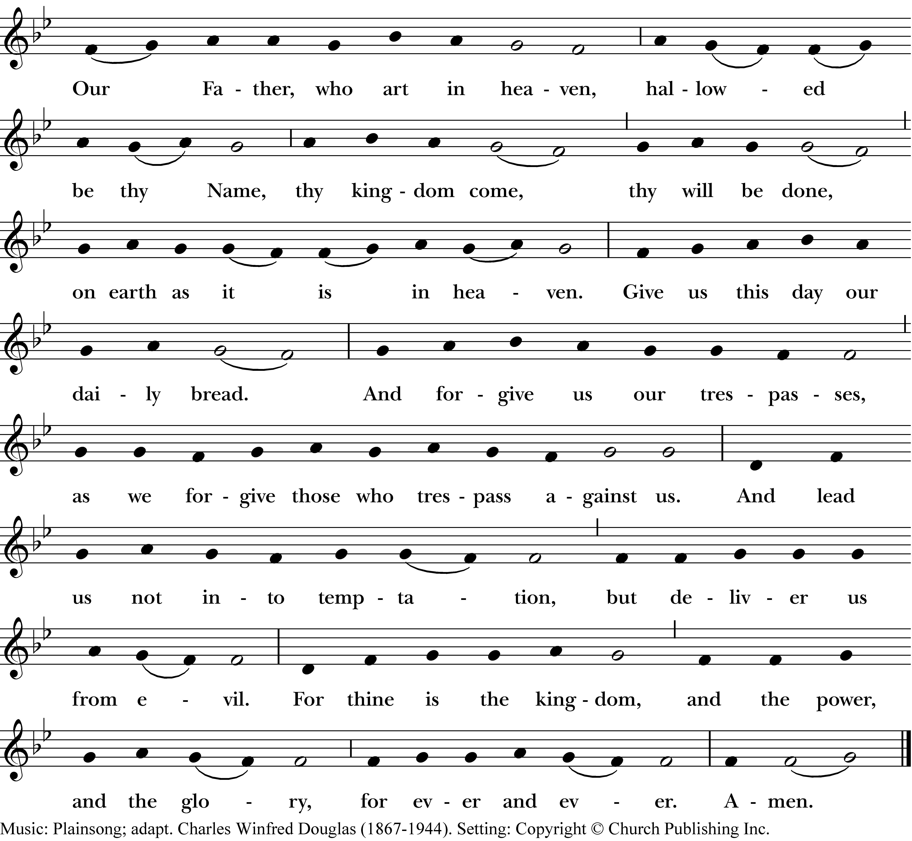

Fraction Anthem Gerald Near

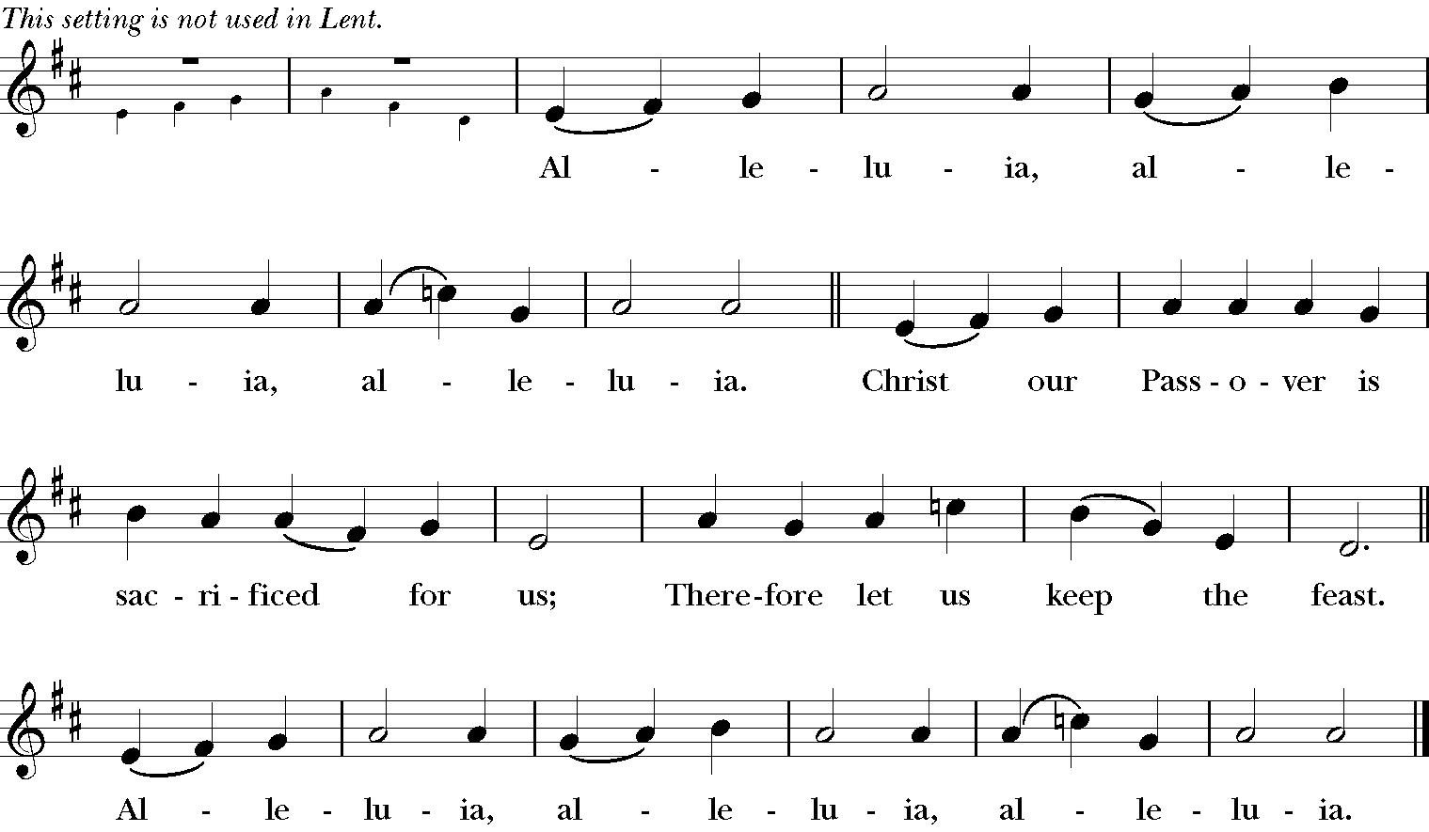

Prayer of Humble Access

We do not presume to come to this thy Table, O merciful Lord, trusting in our own righteousness, but in thy manifold and great mercies. We are not worthy so much as to gather up the crumbs under thy Table. But thou art the same Lord whose property is always to have mercy. Grant us therefore, gracious Lord, so to eat the flesh of thy dear Son Jesus Christ, and to drink his blood, that we may evermore dwell in him, and he in us. Amen.

Invitation

The Gifts of God for the People of God. Take them in remembrance that Christ died for you, and feed on him in your hearts by faith, with thanksgiving.

Communion of the People

All baptized Christians of any age and tradition are invited to receive Holy Communion, and no one who comes to the altar with outstretched hands will be turned away. To receive a blessing instead of the sacrament cross your arms over your chest.

At the altar rail you are welcome to stand or kneel, and to receive either by drinking from the cup or by letting the minister intinct (dip) the bread into the wine for you.

At the floor station all of the bread and wine are free of the top 8 allergens and communion is by intinction only. If you need the sacrament brought to you, please let an usher know.

Communion Hymns
Hymn 178 Alleluia! give thanks (st. 1-3) Alleluia No. 1

Anthem
This joyful Eastertide Hoe groot de vrugten sijn, arr. Charles Wood sung by quartet

The Postcommunion Prayer

Almighty and everliving God, we most heartily thank thee for that thou dost feed us, in these holy mysteries, with the spiritual food of the most precious Body and Blood of thy Son our Savior Jesus Christ; and dost assure us thereby of thy favor and goodness towards us; and that we are very members incorporate in the mystical body of thy Son, the blessed company of all faithful people; and are also heirs, through hope, of thy everlasting kingdom. And we humbly beseech thee, O heavenly Father, so to assist us with thy grace, that we may continue in that holy fellowship, and do all such good works as thou hast prepared for us to walk in; through Jesus Christ our Lord, to whom with thee and the Holy Ghost, be all honor and glory, world without end. Amen.
The Easter Blessing
The God of peace, who brought again from the dead our Lord Jesus Christ, the great Shepherd of the sheep, through the blood of the everlasting covenant: Make you perfect in every good work to do his will, working in you that which is well-pleasing in his sight; and the blessing of God Almighty, the Father, the Son, and the Holy Ghost, be among you, and remain with you always. Amen.

Hymn 175 Hail thee, festival day (stz 1-4) Salve festa dies

The Dismissal
Response: Thanks be to God. Alleluia. Alleluia.

Voluntary
Toccata from Organ Symphony No. V Charles-Marie Widor

If you are visiting Holy Trinity today, welcome! We are so glad you are worshipping with us. Please use this QR code to fill out a visitor card letting us know you were here. You may also complete one of the paper visitor cards in your pew or get one from the greeter outside the chapel. If you would like a nametag, please email parishadmin@htparish.com.

Clergy and Staff
The Rt. Rev. Robert C. Wright
Bishop of the Diocese of Atlanta

The Rev. Greg Tallant
Rector
The Rev. Rhett Solomon
Associate Rector
The Rev. Ellen Echols Purdum
Minister for Evangelism and
New Member Integration

Will Buthod
Minister of Music

Christian Foster

Youth Minister and

Coordinator of Sack Lunch Ministry

Ellen Hopkins

Financial Secretary

Emmy Brown

Co-Parish Administrator

Amanda Vaughn

Communications Minister

Amy Wells

Children’s Minister

Lucas Gray
Children’s Choir Director

David Wesson
Facilities Manag

Vestry

Cindy Stein

Sr. Warden

stein@htparish.com

Alison Gibbs

Jr. Warden

gibbs@htparish.com

Julia Gable

Clerk

gable@htparish.com

Nathan Penner

Treasurer

penner@htparish.com

Gus Brathwaite
HTP Preschool
brathwaite@htparish.com

Jeff Lee
Buildings & Grounds
lee@htparish.com

Laura Manzer
Children’s Formation, Stewardship
lmanzer@htparish.com

Stacy Reece
Parish Life, Communications
reece@htparish.com

David Triemer
Outreach
triemer@htparish.com

Gifts of Flowers & Music for Easter

Flowers are given to the glory of God in thanksgiving for

Berkeley and Nancy Boone
by Ernie and Blanche Holditch

Our children and grandchildren
by Suzie and Tim Ball

Our family - especially our grandchildren - Madeline, Kiley, Elliot, and Layton
by Wanda and Louis Belline

Guy and Charlotte Owens
by Edward and Belinda Watkins

Our godchildren, Hayley and Hayden
by Pete and Charlotte Pfeiffer

Our grandsons: Waylon, Benjamin,
and Coleman
by Fred and Celia Hughes

Thomas Stafford, Jim, Sandy,
and Richard Budd
by Shawn, Hildreth, Sarah Grace,
and Olivia Stafford

Will and the Holy Trinity Parish Choir
by Frank Smith

Our grandchildren
by Ernest and Barbara Ramsay

Flowers are given to the Glory of God in loving memory of

Molly Ahlquist
by Ernie Ahlquist

Tom Gibbs
by Alison, Jackson, and James Gibbs

Tom and Virginia Evans,
Thomas Holland Evans
by Ginna Evans

Russ Wallace
by Tish Wallace

Keiji Yamamori
by Kimiko Miller

Our parents
by Pete & Charlotte Pfeiffer

William and Elizabeth Christian Jackson, Charles Perry Jackson
by Phoebe Jackson

Lanette Wright
by Dick Wright

Laura Bessho
by the Bessho Family

Cecil Waites
by Chotsy Waites

Mavis Boston
by Laura Boston

Paul and Helen Mears
by Bill and Greg Mears

Hilde Amft, Mom and Oma
By Edith Eastman

Music is given to the glory of God in thanksgiving for

Joan Kidd
by Ernie and Blanche Holditch
The Holy Trinity Music Program
by Wanda and Louis Belline

Our godchildren, Hayley and Hayden
by Pete & Charlotte Pfeiffer

Our parish family
by Pete and Ilene Johnson
Our grandsons: Waylon, Benjamin,
and Coleman
by Fred and Celia Hughes

Catalina, Mia, Will, Skylar and Ezra
by Lynne Pickens

My Family in the USA and Barbados
by Anthony Grant
Music is given to the glory of God in loving memory of

Tom Gibbs
by Alison, Jackson, and James Gibbs

Tom and Virginia Evans,
Thomas Holland Evans
by Ginna Evans

William and Loretta Morris, Roland,
and Helen Ball
by Suzie and Tim Ball

Martha and Elmer Blizzard,
June and Arnold Adams
by Sarah, Curt, and Amelia Merrill

Our parents
by Pete & Charlotte Pfeiffer

William and Elizabeth Christian Jackson, Charles Perry Jackson
by Phoebe Jackson

Lanette Wright
by Dick Wright
Linda and Cecil Pickens
by Lynne Pickens

Anita Mottley, Alesia W. Freeman, Reynold Grant, Colette Grifith, Marjorie Thomas, Wayne Carrington, and Carmen Grant
by Anthony Grant

Edward and Sarah S. Berkeley Watkins
by Edward and Belinda Watkins

Russ Wallace
by Tish Wallace

Hope Robinson
by Greg and Emily Tallant

Jean Smith, my sister
by Laura Boston

John and Maggie Hancock
by Bill and Greg Mears

